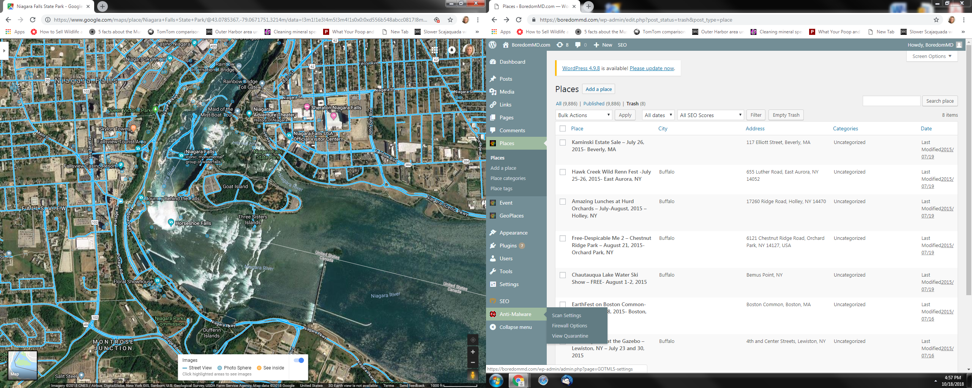

Best View from USA

American Falls

Horseshoe Falls

Fireworks