*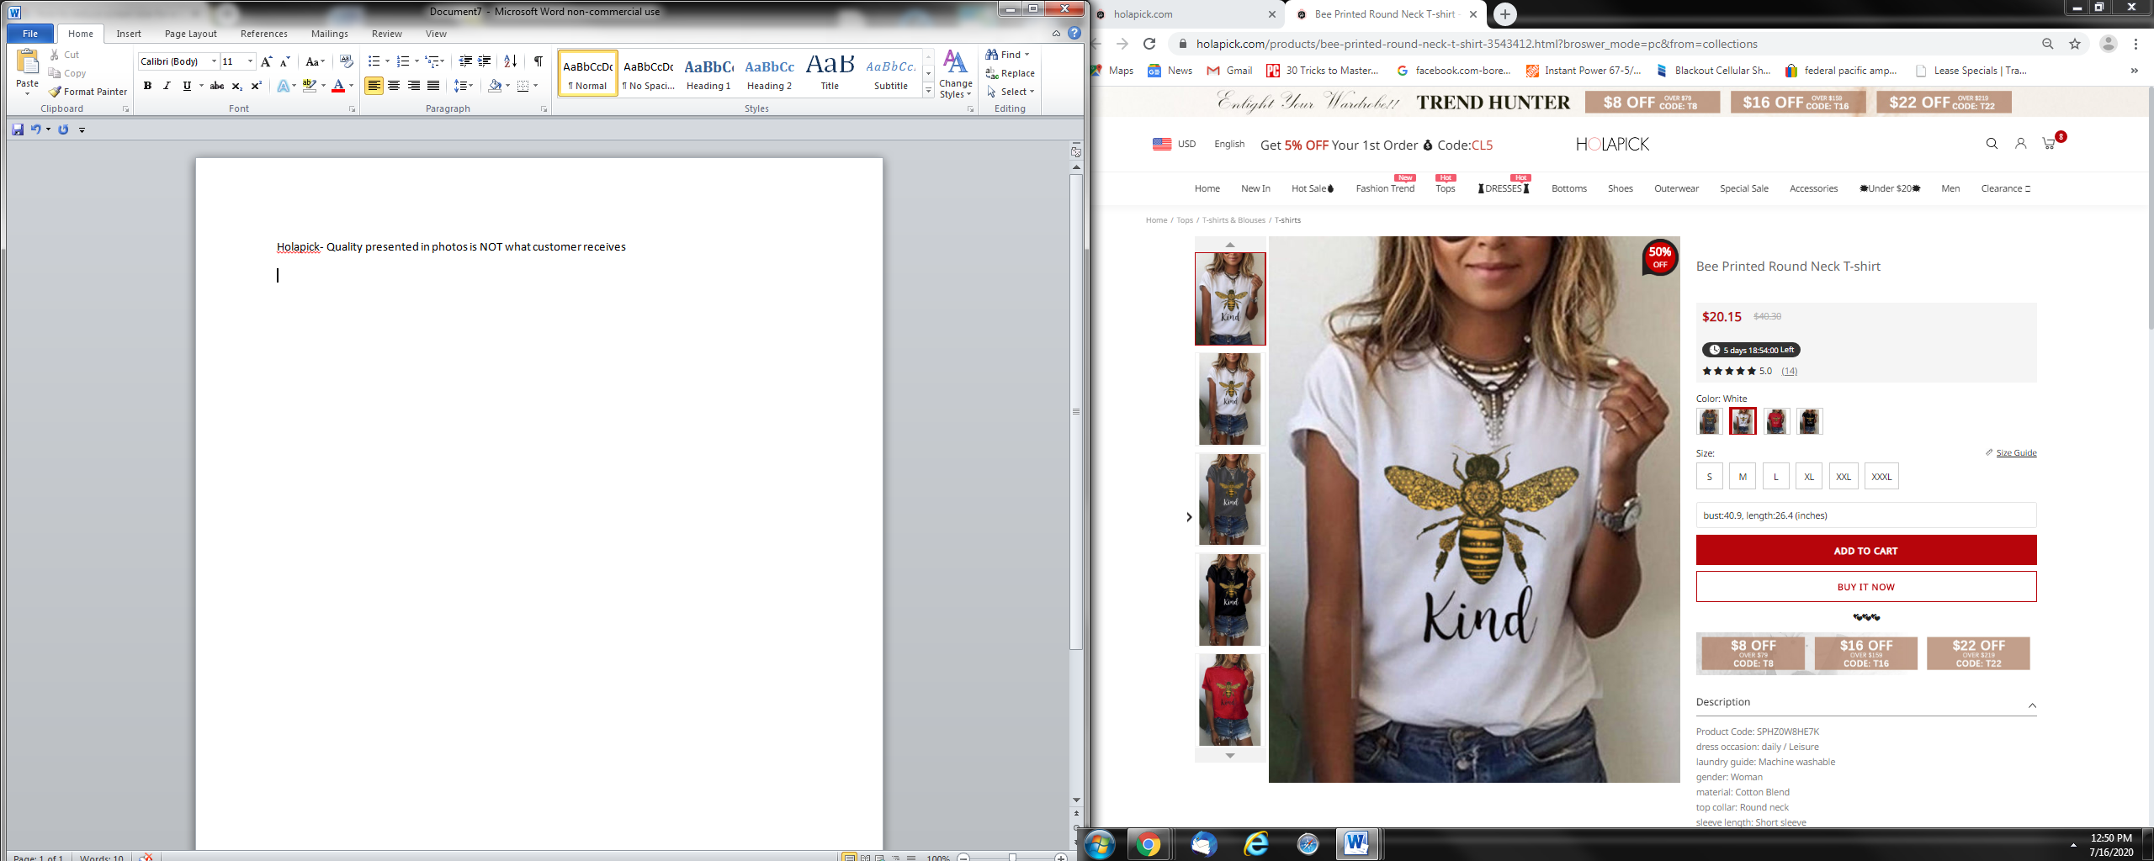*

What Holapick Advertises

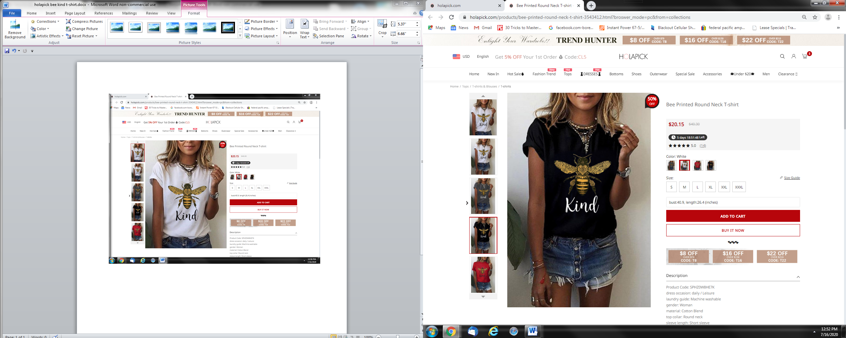

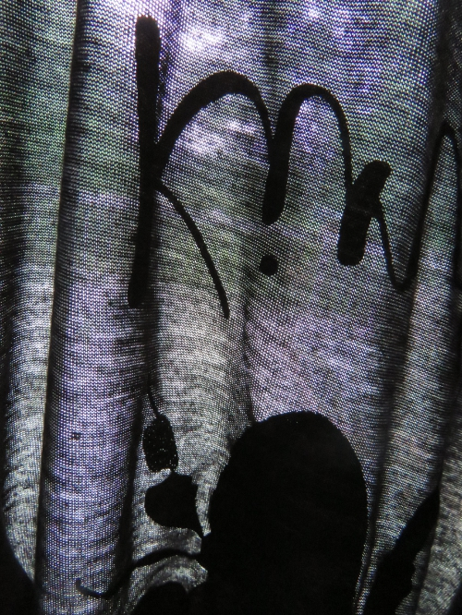

See Through Material

What You Receive- extremely poor quality

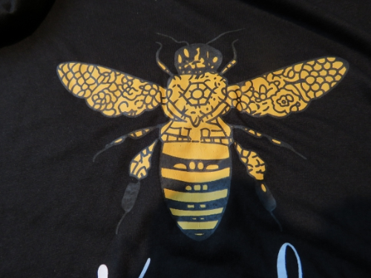

Iron-On Decal for Bee

RETURN POLICY

The issues are as follows:

1. They ship from a US address.
2. You return it to the address it was shipped from.
3. They receive it and then say they will only give you a 50% refund.
4. Check the RETURN policy before you order- they never offer an address- they say email them. Then they offer you a percentage refund or want you to ship it to China.
5. They have multiple locations – first it was LA, then England- United Kingdom, and then Dongguan China.
6. I never got any refund from this company.
7. So, DO NOT ORDER from any company that does not specifically offer an address of where you can return it. Read the copy carefully.