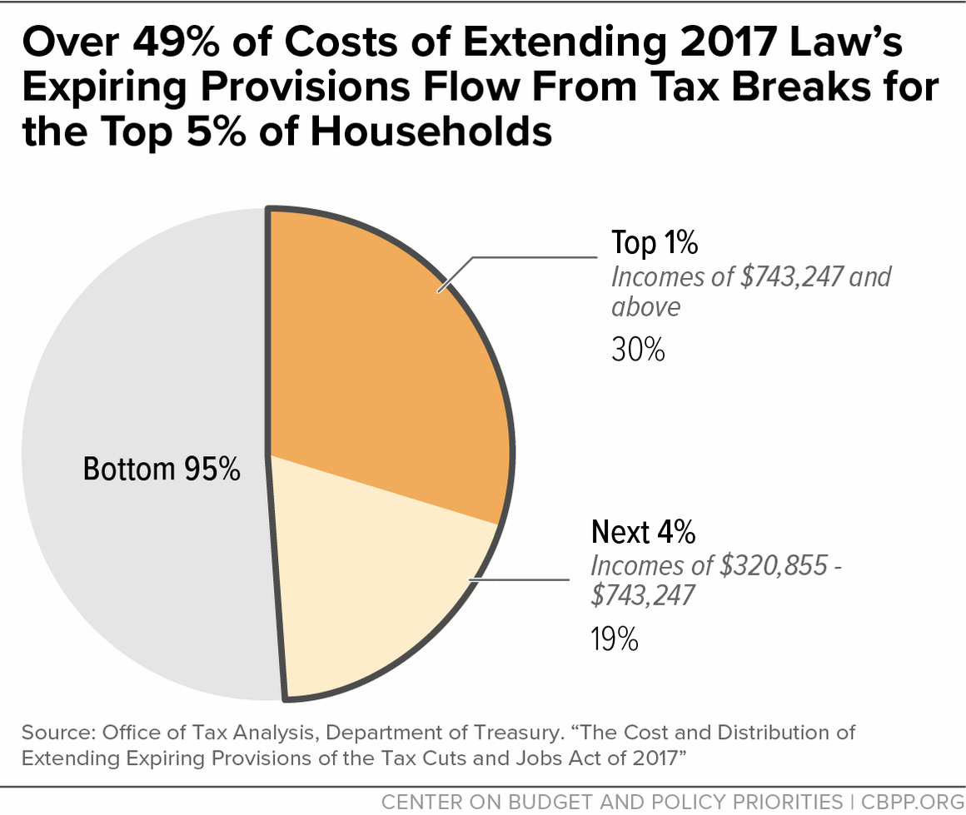

Households with incomes in the top 1 percent (who make more than roughly $743,000 a year) would [get tax cuts](https://home.treasury.gov/system/files/131/The-Cost-and-Distribution-of-Extending-Expiring-Provisions-of-TCJA-01102025.pdf) averaging $61,000 a year, compared to only about $400 for households with incomes in the bottom 60 percent (who make roughly $96,000 or less). Those tax cuts would come on top of the large tax benefits that wealthy people will receive from the 2017 law’s permanent [corporate tax cuts](https://www.cbpp.org/research/federal-tax/congress-should-revisit-2017-tax-laws-trillion-dollar-corporate-rate-cut-in), which are tilted even more heavily toward wealthy people than the expiring individual tax cuts.

***Add trillions in debt, much of it to benefit the wealthy****.* Extending the expiring tax cuts would[cost](https://home.treasury.gov/system/files/131/The-Cost-and-Distribution-of-Extending-Expiring-Provisions-of-TCJA-01102025.pdf) $4.2 trillion over the decade 2026-2035, and roughly half of the benefits would go to people making over roughly $320,000 (that is, people with incomes in the top 5 percent).

As a first step, Congress should [let](https://www.cbpp.org/research/federal-tax/principles-for-the-2025-tax-debate-end-high-income-tax-cuts-raise-revenues-to) the 2017 tax cuts for households with high incomes expire on schedule. Congress also should [expand the Child Tax Credit](https://www.cbpp.org/blog/policymakers-should-expand-the-child-tax-credit-for-the-17-million-children-currently-left-out), especially for the roughly 17 million children who don’t receive the full credit today because their families’ incomes are too low, and [expand the Earned Income Tax Credit](https://www.cbpp.org/blog/about-14-million-low-income-adults-not-raising-children-at-home-would-benefit-from-permanently) for workers not raising children in their home, who now receive little or nothing from the credit.

In addition, Congress should [scale back](https://www.cbpp.org/research/federal-tax/congress-should-revisit-2017-tax-laws-trillion-dollar-corporate-rate-cut-in) corporate tax breaks and reduce the special tax breaks enjoyed by very wealthy households that shield their considerable income from taxation. And Congress should provide the IRS with the funding it needs to enforce the nation’s tax laws and better ensure that wealthy people and corporations pay the taxes they legally owe.