Why The Senate Should NOT Make Corporation Tax Cuts Permanent in the Big Beautiful Bill
The major reason is that many corporations are not paying anything or much now! The 2017 Tax Cuts and Jobs Act would reduce the corporate tax rate from 35% to 21% and will reduce US government revenues by $648 billion. Making permanent the corporate, estate and individual tax rate will reduce the federal tax revenue of individuals by $3.6 trillion, expiring estate taxes by $240 billion and corporate by $648 billion. Economic growth will offset $710 billion of the $4.5 trillion in revenue losses and increase interest costs by $941 billion. If you take the loss of tax cuts and the increase in interest costs, it increases the deficit by $5.4 trillion. The tax code needs to be revised, this is not it.Source-Tax Foundation- https://taxfoundation.org/research/all/federal/tax-cuts-and-jobs-act-tcja-permanent-analysis/
Nearly 50 companies in the S&P 400 did not pay any income taxes in 2023. And these companies had a credit.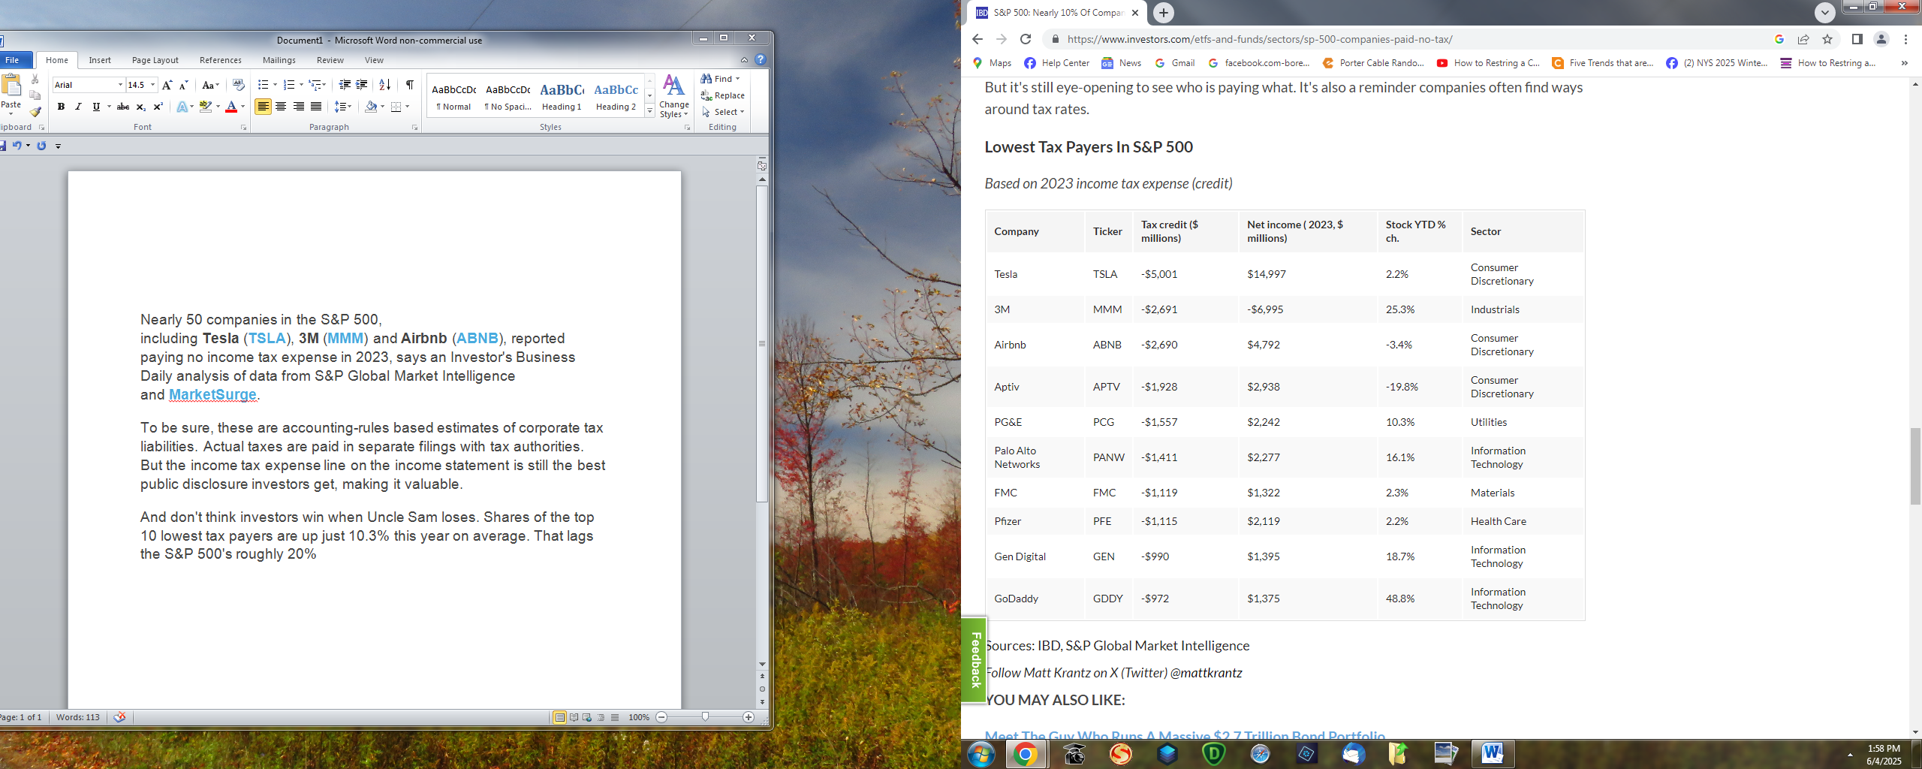
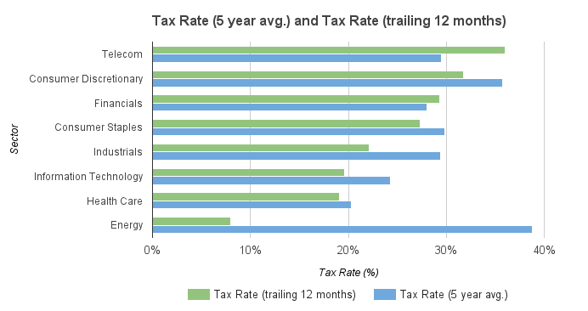

Tax rates for the 50 largest companies in the S&P 500 (5 year average and trailing 12 months):

Ticker | Company Name | Tax Rate (5 year avg.) | Tax Rate (trailing 12 months) | Sector | Industry | Rank
AMGN | Amgen Inc | 10% | 14% | Health Care | Biotechnology | 1
CELG | Celgene Corp | 14% | 19% | Health Care | Biotechnology | 2
BMY | Bristol-Myers Squibb Co | 16% | 23% | Health Care | Pharmaceuticals | 3
ABBV | AbbVie Inc | 17% | 22% | Health Care | Biotechnology | 4
QCOM | QUALCOMM Inc. | 17% | 17% | Information Technology | Semiconductors & Semiconductor Equipment | 5
CSCO | Cisco Systems Inc | 17% | 17% | Information Technology | Communications Equipment | 6
MDT | Medtronic PLC | 19% | 6% | Health Care | Health Care Equipment & Supplies | 7
GOOG | Alphabet Inc. | 19% | 15% | Information Technology | Internet Software & Services | 8
JNJ | Johnson & Johnson | 19% | 17% | Health Care | Pharmaceuticals | 9
GILD | Gilead Sciences Inc | 20% | 19% | Health Care | Biotechnology | 10
VZ | Verizon Communications Inc | 21% | 36% | Telecommunication Services | Diversified Telecommunication Services | 11
IBM | International Business Machines Corp | 21% | 5% | Information Technology | IT Services | 12
BAC | Bank of America Corp | 21% | 31% | Financials | Banks | 13
ORCL | Oracle Corp | 22% | 23% | Information Technology | Software | 14
MSFT | Microsoft Corp | 22% | 15% | Information Technology | Software | 15
NKE | Nike Inc | 23% | 16% | Consumer Discretionary | Textiles, Apparel & Luxury Goods | 16
KO | Coca-Cola Co (The) | 24% | 21% | Consumer Staples | Beverages | 17
PG | Procter & Gamble Co (The) | 24% | 25% | Consumer Staples | Household Products | 18
MRK | Merck & Co Inc. | 24% | 19% | Health Care | Pharmaceuticals | 19
INTC | Intel Corp | 25% | 19% | Information Technology | Semiconductors & Semiconductor Equipment | 20
HON | Honeywell International Inc | 25% | 25% | Industrials | Industrial Conglomerates | 21
PEP | PepsiCo Inc | 25% | 23% | Consumer Staples | Beverages | 22
PFE | Pfizer Inc | 26% | 14% | Health Care | Pharmaceuticals | 23
GE | General Electric Co | 26% | -8% | Industrials | Industrial Conglomerates | 24
AAPL | Apple Inc | 26% | 26% | Information Technology | Technology Hardware, Storage & Peripherals | 25
USB | U.S. Bancorp | 27% | 27% | Financials | Banks | 26
V | Visa Inc | 27% | 25% | Information Technology | IT Services | 27
BA | Boeing Co | 27% | 6% | Industrials | Aerospace & Defense | 28
JPM | JPMorgan Chase & Co | 27% | 29% | Financials | Banks | 29
UTX | United Technologies Corp | 28% | 32% | Industrials | Aerospace & Defense | 30
MA | Mastercard Inc | 28% | 25% | Information Technology | IT Services | 31
MMM | 3M Co | 29% | 28% | Industrials | Industrial Conglomerates | 32
PM | Philip Morris International Inc | 29% | 27% | Consumer Staples | Tobacco | 33
WBA | Walgreens Boots Alliance Inc | 30% | 20% | Consumer Staples | Food & Staples Retailing | 34
C | Citigroup Inc | 30% | 30% | Financials | Banks | 35
WFC | Wells Fargo & Co | 31% | 32% | Financials | Banks | 36
GS | Goldman Sachs Group Inc (The) | 31% | 27% | Financials | Capital Markets | 37
WMT | Wal-Mart Stores Inc | 32% | 28% | Consumer Staples | Food & Staples Retailing | 38
MCD | McDonald's Corp | 32% | 31% | Consumer Discretionary | Hotels Restaurants & Leisure | 39
T | AT&T Inc | 33% | 35% | Telecommunication Services | Diversified Telecommunication Services | 40
UPS | United Parcel Service Inc | 34% | 34% | Industrials | Air Freight & Logistics | 41
DIS | Walt Disney Co (The) | 34% | 34% | Consumer Discretionary | Media | 42
CMCSA | Comcast Corp | 35% | 37% | Telecommunication Services | Diversified Telecommunication Services | 43
MO | Altria Group Inc | 36% | 36% | Consumer Staples | Tobacco | 44
HD | Home Depot Inc. (The) | 36% | 37% | Consumer Discretionary | Specialty Retail | 45
UNH | Unitedhealth Group Inc | 39% | 41% | Health Care | Health Care Providers & Services | 46
XOM | Exxon Mobil Corp | 39% | 8% | Energy | Oil, Gas & Consumable Fuels | 47
CVS | CVS Health Corp | 39% | 39% | Consumer Staples | Food & Staples Retailing | 48
FB | Facebook Inc | 43% | 29% | Information Technology | Internet Software & Services | 49
AMZN | Amazon.com Inc | 58% | 40% | Consumer Discretionary | Internet & Direct Marketing Retail | 50

